Using Altium

Work in Progress. The idea of this document is every time you have to look something up or figure out something with regards to using Altium, throw it in this document. In my opinion, Altium’s online documentation is pretty confusing and hard to follow. For example, they would say “do x from menu y” without explaining how to get to menu y. Because of this, we have this document to lay out how to do things in Altium outlined as simply as possible.

**1. Shortcuts** **1**

**2. Renewing the Team Altium License** **1**

2.1 Example Application Form 2

**3. Schematic to PCB** **4**

Revision History **6**

# 1. Shortcuts

| Key Combination | Action |
| --- | --- |
| p | Open Place menu |
| j | Open find menu |
| Click on part of track then tab | Selects entire track |
| Ctrl+shift+scroll wheel | Change layers |
| Shift+Spacebar (while making polygon) | Change corner type |

# 2. Renewing the Team Altium License

**Author: Rob Keen**

Must be done annually around the beginning of November. Complete the form at <https://www.altium.com/solutions/academic-programs/team-sponsorships> and you should get an email from Altium a few days later (method as of November 8th, 2021).

**Important Note:** Make sure the email in the registration form is one that is registered under an administrator in the Altium dashboard (<https://dashboard.live.altium.com>). This way, the existing license will get updated instead of needing to make a completely new workspace. If the existing workspace does not get updated, reach out to Altium. Can be checked through the above linked Altium dashboard.

University address for easy copy-pasting: 3800 Finnerty Rd, Victoria, CA V8P 5C2

## 2.1 Example Application Form

The following is an example completed form that resulted in a successful Altium sponsorship:

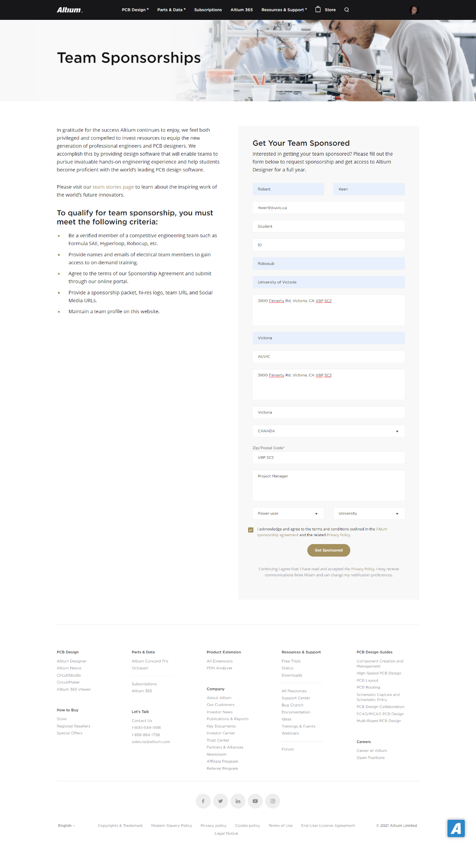



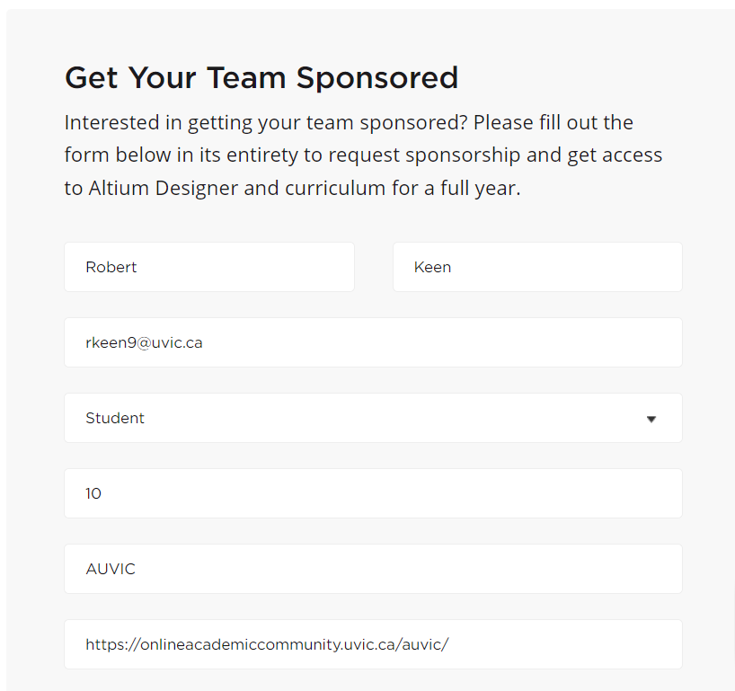

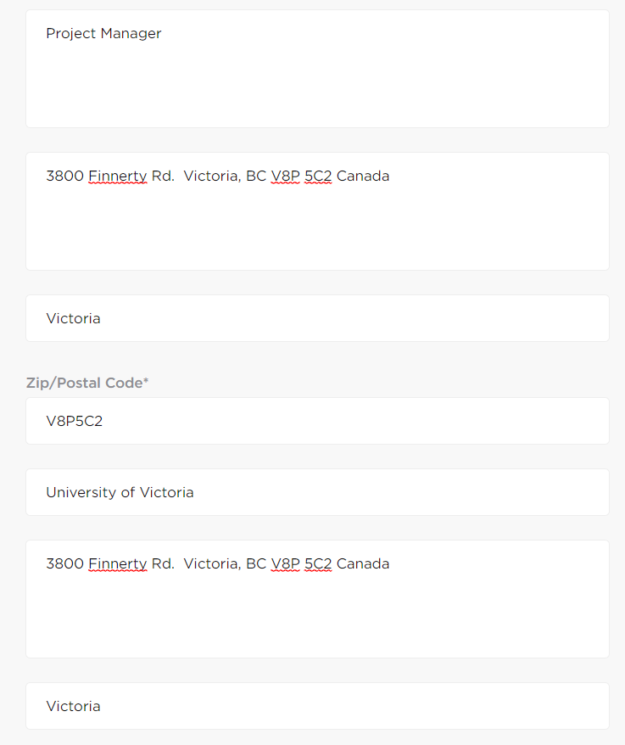

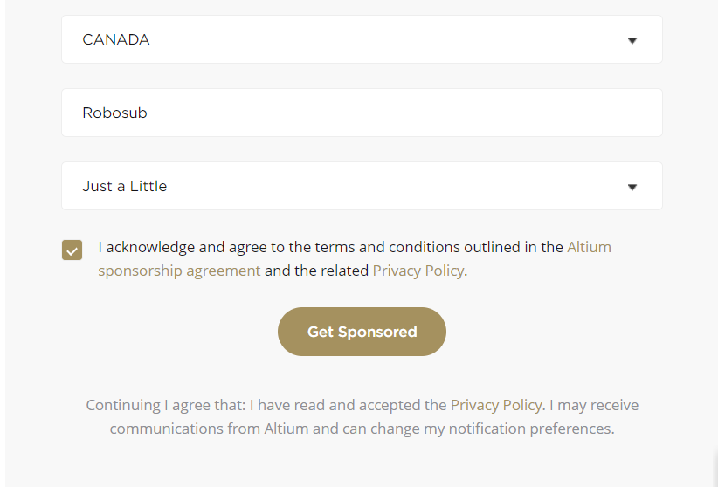

# 3. Schematic to PCB

**Author: Rob Keen**

1. Create new .PcbDoc file by right clicking on the project in the projects tab and choosing “Add New to Project>PCB”  
   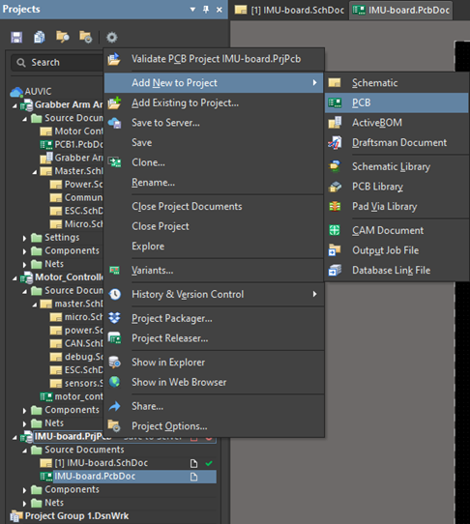
2. Enter the new document, save with ctrl+s, and name the file whatever you want
3. “Design>Import changes From filename.PrjPcb”  
   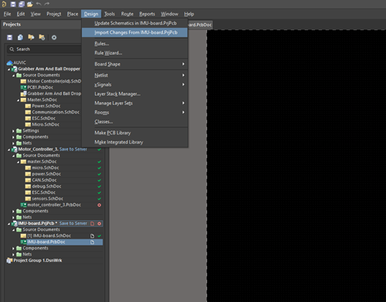
4. From the Engineering Change Order window that appears, “Validate Changes” and address any errors that come up  
   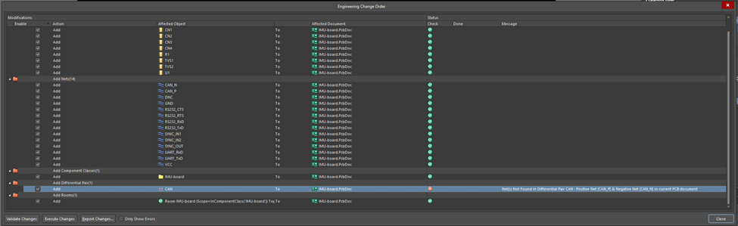  
   Note: the above error can be safely ignored
5. Once errors are addressed click “Execute Changes”
6. You are now ready for routing

# 4. Differential Pair Routing

**Author: Rob Keen**

**Sources:** [**https://www.altium.com/documentation/altium-designer/pcb-dlg-managediffpairsformcreate-differential-pairs-from-nets-ad**](https://www.altium.com/documentation/altium-designer/pcb-dlg-managediffpairsformcreate-differential-pairs-from-nets-ad)

## 4.1 Getting to the Differential Pair Editor

1. With the .PcbDoc file open, show the PCB panel by clicking “View>Panels>PCB”  
   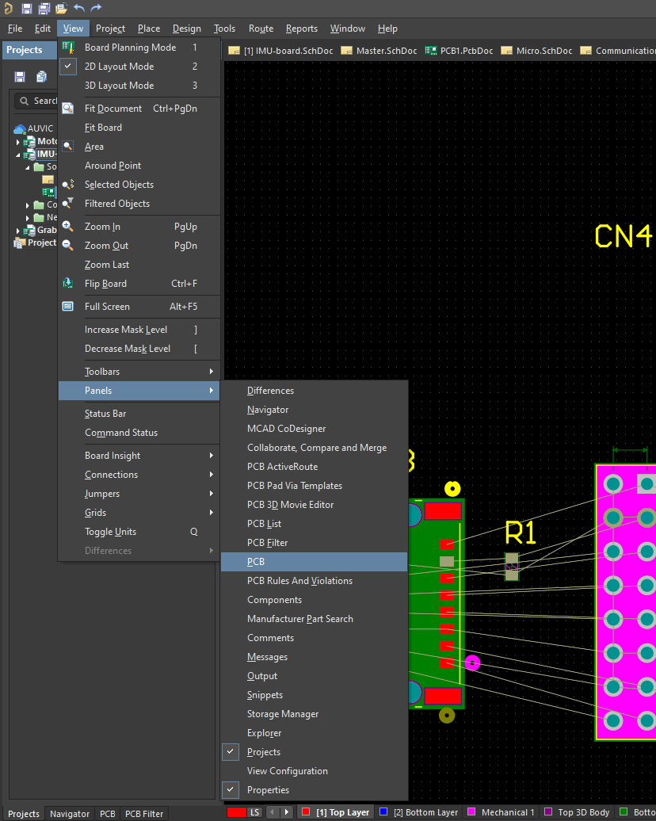
2. Open the PCB panel, click the drop down menu at the top (by default it says “Nets”) and choose “Differential pairs Editor”  
   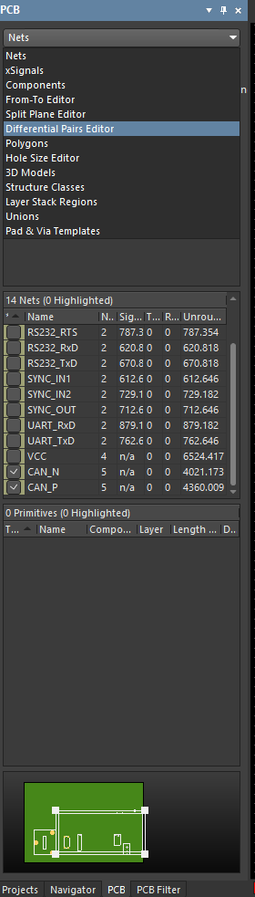

# Revision History

| **Name** | **Date** | **Revision Details** |
| --- | --- | --- |
| Robert Keen | Nov. 8, 2021 | Initial release |
| Robert Keen | Nov. 20, 2021 | Converted this document into a generic using Altium document |